2. Requirement Analysis Phase

Date | 30-09-2026
Team ID | SWTID-2026-3204
Project Name | Auto-Ticket-Classification-using-Flow-Designer
Maximum Marks | 4 Marks

Objective

To understand and define the functional requirements, ticket information, classification conditions, support groups, automation steps, and expected outcomes required for the Auto Ticket Classification process.

Activities Performed

- Identify the users who create and manage support tickets.
- Identify the fields required for ticket classification.
- Define the information required from the requester.
- Identify the different ticket categories.
- Define the conditions used to identify each category.
- Identify the support group responsible for each category.
- Define the trigger that starts the Flow Designer automation.
- Define the actions that should occur after classification.
- Define the process for updating the ticket category.
- Define the process for assigning the ticket to the appropriate support group.
- Identify the need for status updates and process visibility.
- Define expected results for successful and unsuccessful classification.

Functional Requirements

The system should:

- Detect when a new ticket is created.
- Read the relevant ticket information.
- Check the predefined classification conditions.
- Identify the appropriate ticket category.
- Assign the appropriate support group.
- Update the ticket with the classification result.
- Maintain the ticket status and assignment information.

Input Requirements

The flow may use the following ticket information:

- Short Description
- Description
- Category
- Priority
- Requester
- Issue Type
- Assignment Group

Classification Requirements

The system should identify tickets based on predefined conditions.

For example:

Password/Login → Access/Account

Laptop/Printer → Hardware

Application/System → Software

Internet/Connectivity → Network

Expected / Produced Output

The requirement analysis results in a clear automated workflow:

Ticket Submission → Validation → Classification Condition → Category Assignment → Support Group Assignment → Ticket Update → Completion

The output of this phase is a defined set of functional requirements and classification rules that can be used during project design and development.

Screenshots

Screenshot 1
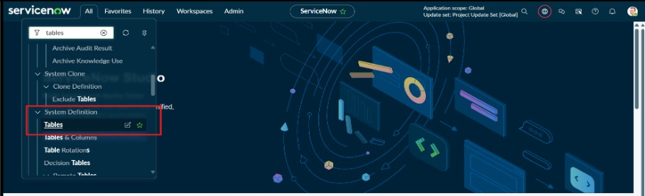
Screenshot 2
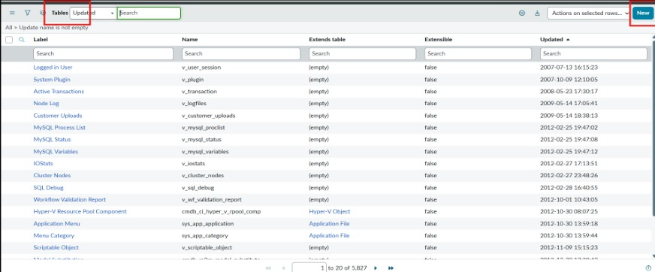
Screenshot 3
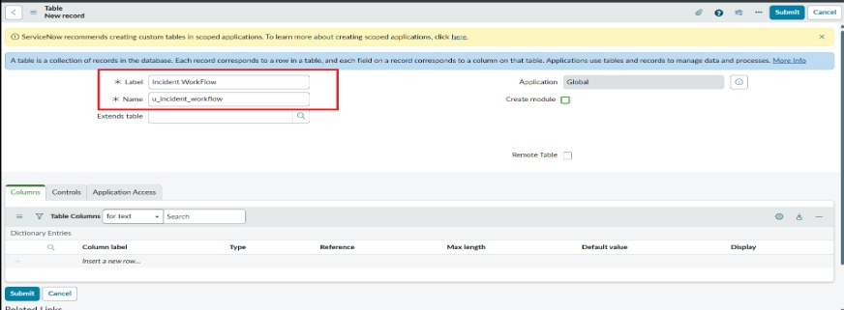
Data Flow Diagram
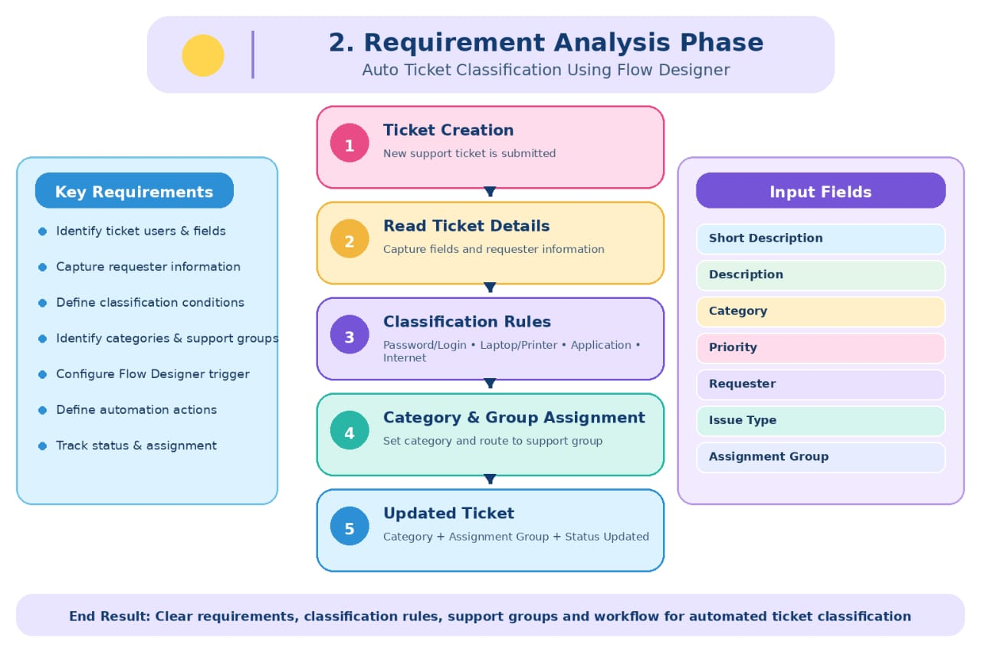

Conclusion

The requirement analysis phase defines what the Auto Ticket Classification system should do and what information is required to perform the classification. These requirements provide the foundation for designing and developing the Flow Designer automation.

